The outcome of using a single cage in posterior lumbar interbody fusion in management of lumbar instability
H.S.Shoukry, M.M. El Karamany, A.I.Bakr, M.G. El Ashhab, G.H. Kazem
Orthopedic, Dept., Faculty of Medicine, Benha Univ., Benha, Egypt
Email: Shoukry @gmail.com
Abstract
Posterior Lumbar Interbody Fusion have standed the test of time as an effective method for managing lumbar instability. This study aimed to asses and evaluate the outcome of using a single cage in posterior lumbar interbody fusion as a surgical treatment modality for symptomatic lumbar instabilities. The study include 20 patients, 9 were males (45 %) but 11 were females (55%). Mean of age was 53 ±14, the mean BMI was 28.5. About one-quarter were smokers (25.0%). All patients had leg pain, and most of them (85%) had back pain. more than half of the studied patients showed L5/S1 affection. About one-third showed L4/5 affection. Only 10% and 5% showed L3/4 and L2/3 affection. VAS score of leg pain showed an overall significant difference. Oswestry Disability Index (ODI) score showed an overall significant difference. Post-operative complication showed that two patients showed cage posterior migration. One patient showed screw malposition, and one patient showed superficial infection. The Patients’ satisfaction reported that most patients (70.0%) reported excellent outcomes. Only 20% and 10% reported good or fair outcomes. Single cage in posterior lumbar interbody fusion for treatment of lumbar instability enables sufficient decompression and produce satisfactory clinical outcomes and radiological outcomes.
Keyword: Single cage; PLIF; lumbar instability

1. Introduction
Spinal instability is widely accepted as a cause of back pain and also dynamic compression on the neural elements. This has been advocated as a classic indication for spinal fusion procedures [1].
The lumbar fusions aim at relieving the pain, maintaining a corrected spine after deformity or avoiding progressive neurological deterioration due to instability. However, this happens on the expense of losing the spinal motion in the fused segments [2].
The clinical outcome of lumbar spinal fusion is correlated with achievement of bony fusion. These implant materials result in a high rate of fusion only when combined with other osteoconductive and osteoinductive agents. Achieving bone integration with an interbody implant is likely to aid fusion and improve implant longevity by limiting subsidence and stress shielding and associated complications[3].
Weiler et al estimated that about 20 to 30 % of patient with back pain had some element of spinal instability. However, low back pain is not an accurate predictor of spinal instability, still. The gold standard for detection of spinal instability remains the radiologic evidence, rather than symptomatology or clinical examination [1].
Different functional lateral spinal radiographs have been proposed to detect instability. The most widely accepted modalities are the flexion-extension lateral and standing neutral lateral view radiograph. [1].
CT scanning is not the modality of choice to confirm spinal instability in non-traumatic setting. However, several parameters on CT imaging, have been studied, that could point out to a potential spinal instability; e.g. facet joint opening and orientation, vaccum phenomenon, osteophytes and subchondral sclerosis. [4].
MRI is considered the gold standard for diagnosing the spinal degenerative changes, except for the vacuum phenomenon. The MRI is of value in predicting instability. [5].
The principal indication for lumbar interbody fusion surgery is the treatment of symptomatic spondylolisthesis, degenerative scoliosis, and spinal stenosis associated with instability[6].
For those with lumbar stenosis without instability, the surgical management has traditionally involved posterior decompressive procedures, including laminectomy or laminotomy, and judicious use of partial medial facetectomies and foraminotomies, with or without discectomy. In patients with evidence of spinal instability, however, in situ posterior lumbar fusion is recommended as a treatment option in addition to decompression in the setting of lumbar stenosis. [7].
Secondary indications include recurrent lumbar disc herniation, where extensive bony removal is necessary for exposure of the disc fragments, lateral or massive disc herniations, failed previous lumbar fusions by other techniques, and discogenic low back pain. [8].
The problems with early PLIF technique were mainly that the compressive strengths of the allograft were not adequate and the fusion rates were low. That led to the development of Carbon Fiber Reinforced Polymer (CFRP) cages, which enhanced the mechanical strength by their load sharing property. [9].
Nowadays, PLIF with two interbody cages, one on each side (bilateral), usually Poly-Ether-Ether-Ketone (PEEK) is the standard treatment. This helps to restore the alignment, disc height, the load bearing of the anterior structures and provide higher fusion rates. However, it comes with a high cost in terms of extensive laminectomy, bilateral facetectomy and unnecessary trauma to the lumbar musculoligamentous complex. [10].
In this study, we are aiming to evaluate the outcomes of using only a single interbody cage in PLIF with laminectomy, unilateral facetectomy and bilateral standard pedicular screw fixation. Theoretically, this will decrease the morbidity upon the patients (in terms of decreased operative time, decreased blood loss, lumbar musculoligamentous complex trauma and probably hospital stay), while allowing us to restore the disc height, indirect foraminal decompression, restore the alignment and balance to the lumbar spine.

2. Patients and methods
This study has been conducted on 20 cases of symptomatic lumbar instabilities who have failed medical treatment at the orthopedic department, faculty of medicine, Benha university hospitals.
- Inclusion criteria:
This study include 20 cases of symptomatic lumbar instabilities who have failed medical treatment which includes one or more of the following
- Evident instability on radiographic evaluation (static and dynamic films)
- Including those who have been previously operated or not Associated with inefficiency in daily activities
- Exclusion criteria:
Any cases the following criteria excluded
- Incomplete radiological documentation
- Inaccurate radiological documentation before or after the surgery
- Anticipated poor cooperation of the patient.
- Methods of diagnosis:
- All patients are evaluated clinically by history and physical examination. Special attention is directed towards associated neurology, previous spine procedures, gait disturbance, limb length discrepancy, asymmetry of the spine and any change in body habitus and posture.
- All the patients have standing radiographs lumbosacral spine (Anteroposterior and lateral views).
- All the patients have dynamic lateral radiographs lumbosacral spine, measuring the degree of the angulation and translation.
- Assessment and outcome evaluation:
Assessment and outcome evaluation include:
Patient’s history:
- Clinical history was taken from the patient in the sort of name, sex, age, job, address and smoking habits.
- Associated illness like diabetes, hypertension and cardiac condition.
- Patients were asked about the mechanism of injury and if there is any associated injuries.
Clinical examination:
The clinical manifestations of spinal stability fall into three categories
- Neurologic deficit due to cord, cauda equina, or nerve root compression
- Pain
- Incapacitating deformity
Radiological evaluation:
The bony union was evaluated with careful assessment of the formation of bone bridging and the absence of radiolucency around the cages. A solid bony union was considered to be obtained when the endplates became invisible on the follow-up radiographs, and bony trabecular continuity and bone bridging were observed in the intervertebral space. Fusion failure was defined as the presence on anteroposterior and lateral radiographs of a definite radiolucent line around a cage or pedicle screw or more than 5° of motion on lateral flexion extension radiographs. The height of the intervertebral disc space was calculated as the mean of the sum of the vertical distances between the anterior and posterior edges of the vertebral endplates.
- Clinical improvement:
Clinical improvement over a six month period as measured by:
- Visual Analogue Score (VAS):
We used the visual analog scale (VAS) is a pain rating scale first used by Hayes and Patterson in 1921. Scores are based on self-reported measures of symptoms that are recorded with a single hand written mark placed at one point along the length of a 10-cm line that represents a continuum between the two ends of the scale—“no pain” on the left end (0 cm) of the scale and the “worst pain” on the right end of the scale (10 cm).Measurements from the starting point (left end) of the scale to the patients' marks are recorded in centimeters and are interpreted as their pain.
- The Oswestry Disability Index :
Section 1 – Pain intensity
Section 2 – Personal care
Section 3 – Lifting
Section 4 – Walking
Section 5 – Sitting
Section 6 – Standing
Section 7 – Sleeping
Section 8 – Sex life (if applicable)
Section 9 – Social life
Section 10 – Travelling
- Surgical technique:
Fitness to surgery:
The patients were assessed for fitness for surgery by clinical history, examination and routine pre-operative laboratory investigations.
Consent:
Standard consent was taken from the patients.
Surgical procedure:
- Operating room setup
- The patient is taken to the operating room and placed prone on a radiolucent operating table.
- Fluoroscopy C-Arm is used throughout the procedure.
- The spine is approached through a standard posterior midline incision including exposure out to the tips of the transverse processes so that an adequate intertransverse fusion can be performed.
- Pedicle screw placement is undertaken via a standard approach.
- Decompression is initiated with a laminectomy in the midline, exposing the ligamentum flavum.
- The ligamentum is carefully removed, and hemostasis is obtained. A unilateral facetectomy is then performed.
- Once the posterior bone elements are resected and the decompression is complete, the dura and neural elements are mobilized. The goal is to be able to access the posterior anulus and disc space easily without any dural tension.
- Distraction through the PLIF level helps facilitate interbody placement, achieved by a lamina spreader or distraction on the contralateral pedicular screws.
- A safe triangular window is identified between the exiting, traversing roots and the pedicle. This window is enlarged using Kerrison rongeurs. A window that is a minimum of 10 mm in size facilitates disc space preparation.
- Disc space preparation is performed using a combination of curettes, pituitary rongeurs, and end-plate preparation tools. Thorough disc-space preparation is critical for both correcting the deformity and obtaining a solid fusion.
- The disc space is sized for an appropriate interbody cage. The anterior aspect of the disc space and the cage are both packed with bone graft. This may involve the use of iliac crest graft, local bone, or bone substitutes, depending on the specific clinical situation.
- The single Cage and bilateral pedicular screws position is verified by biplane radiography and lordosis is restored by compression across the screws bilaterally.
- If the lateral gutters have been exposed, grafting in this region is undertaken as well. Care must be taken with graft placement on the PLIF side as facet and pars resection leaves the exiting route exposed.
- Closure is undertaken in a standard fashion.
Postoperative care:
The patients are admitted to the hospital .the patients receive intravenous antibiotics and pain medication as require. The patient is typically mobilized out of bed the day after surgery.
Follow up:
Patients were asked to return to hospital for follow-up at 4 weeks, 3 months, and 6 months for clinical and radiographic assessment.
- Statistical methods
Data management and statistical analysis were done using SPSS version 25. (IBM, Armonk, New York, United States). Quantitative data were assessed for normality using the Shapiro-Wilk test and direct data visualization methods. Then, numerical data were summarized as means and standard deviations or medians and ranges. Categorical data were summarized as numbers and percentages. VAS score and ODI were compared at different times using Friedman’s test. Post hoc analyses were Bonferroni corrected. All statistical tests were two-sided. P values less than 0.05 were considered significant.

3. Results:
This study included 20 cases of symptomatic lumbar instabilities who have failed medical treatment. The mean age of the studied patients was 53 years with a standard deviation of 14 years. Regarding gender, more than half of the patients were females (55.0%).

The mean BMI was 28.5. About one-quarter were smokers (25.0%). (Table 1)

Table (1) General characteristics of the studied patients
Age (years) | Mean ±SD | 53 ±14
Gender | Males n (%) | 9 (45.0)
 | Females n (%) | 11 (55.0)
BMI | Mean ±SD | 28.5 ±4.3
Smoking | N (%) | 5 (25.0)
- Level of affection of the studied patients
More than half of the studied patients showed L5/S1 affection. About one-third showed L4/5 affection. Only 10% and 5% showed L3/4 and L2/3 affection, respectively. (Table 2)
Table (2) Level of affection of the studied patients
 |  | n (%)
Level of lesion | L2/3 | 1 (5.0)
 | L3/4 | 2 (10.0)
 | L4/5 | 6 (30.0)
 | L5/S1 | 11 (55.0)
- Presenting symptoms of the studied patients
All patients had leg pain, and most of them (85%) had back pain
Table (3) Presenting symptoms of the studied patients
 | N (%)
Leg pain | 20 (100.0)
Back pain | 17 (85.0)
- VAS score
VAS score of leg pain showed an overall significant difference (P-value < 0.001). Post hoc analysis revealed that it was significantly higher pre-operative (8) compared to 3 months (2) and 12 months (1), with no significant difference between 3 and 12 months.
Table (4) VAS score of leg pain at pre-operative, 3 months, and 12 months
VAS | Median (range) | P-value
Pre-operative | 8 (7 - 10) ª | < 0.001
At 3 months | 2 (1 - 7) ^{b}
At 12 months | 1 (0 - 2) ^{b}
- Oswestry disability index (ODI)
Oswestry Disability Index (ODI) score showed an overall significant difference (P-value < 0.001). Post hoc analysis revealed that it was significantly higher pre-operative (50) compared to 3 months (20) and 12 months (10). Also, it was significantly higher at 3 months compared to 12 months.
Table (5) ODI at preoperative, 3 months, and at 6 months
ODI | Median (range) | P-value
Pre-operative | 50 (34 - 90) ª | < 0.001
At 3 months | 20 (8 - 64) ^{b}
At 12 months | 10 (4 - 72) ^{c}
- Complications:
Two patients showed cage posterior migration. One patient showed screw malposition, and one patient showed superficial infection.
Table (6) Distribution of complications.
 | n (%)
Cage posterior migration | 2 (10.0)
screw malposition | 1 (5.0)
superficial Infection | 1 (5.0)
No complications | 16 (80.0)
- Patients’ satisfaction
Most patients (70.0%) reported excellent outcomes. Only 20% and 10% reported good or fair outcomes, respectively.
Table (7) Satisfaction grade of the studied patients
 |  | n (%)
Satisfaction | Fair | 2 (10.0)
 | Good | 4 (20.0)
 | Excellent | 14 (70.0)

Case presentation:
Case 1:
51 year old male with back pain and bilateral leg pain. Had an L5/S1 decompression and PLIF.
Preoperative:
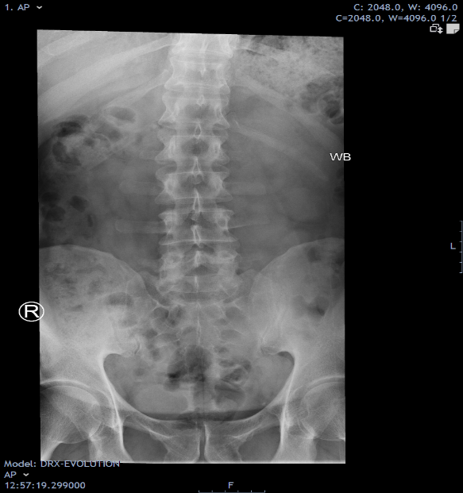
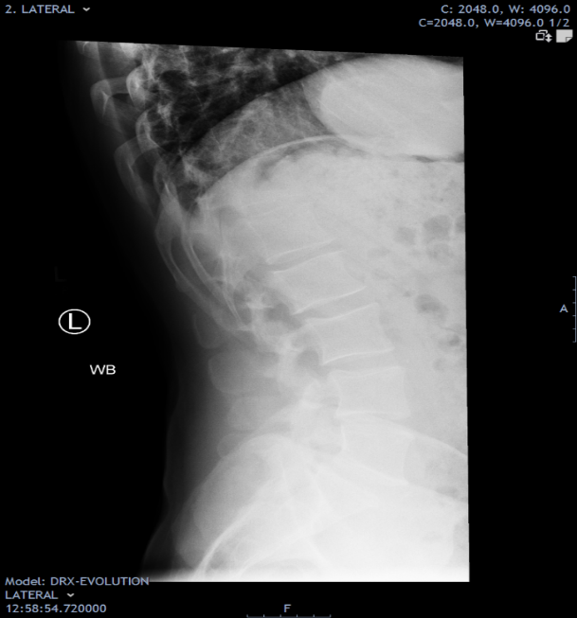
Preoperative MRI (Bilateral foraminal stenosis, more on RT).

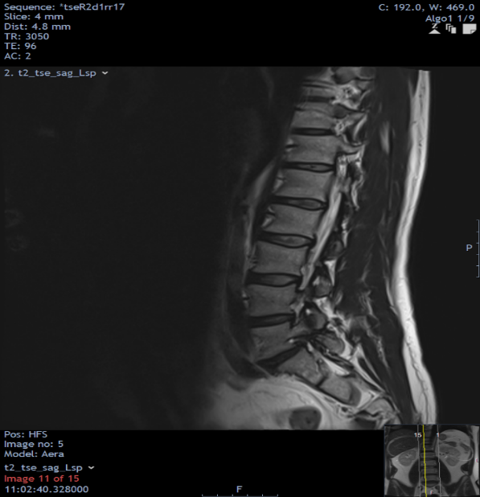

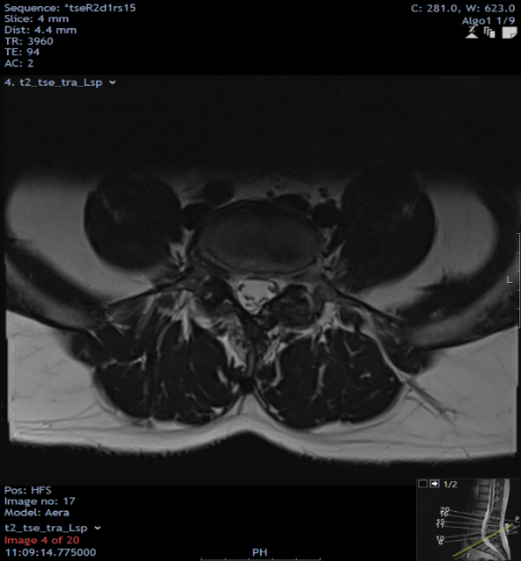

Intraoperative:

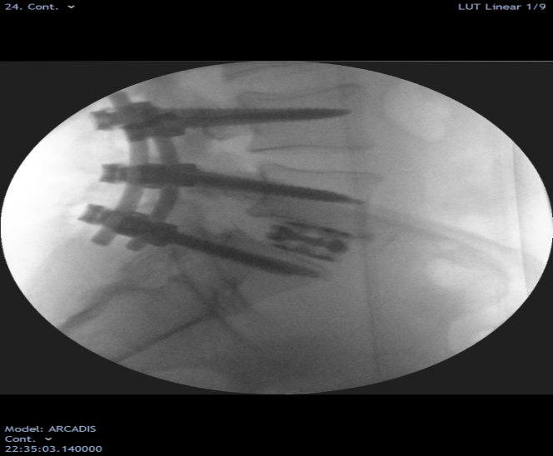

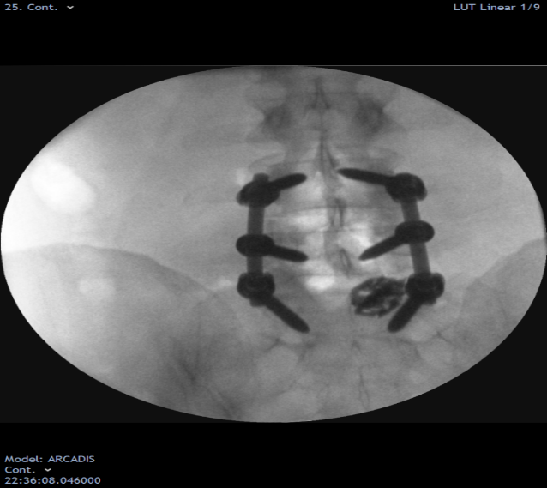

Postoperative:

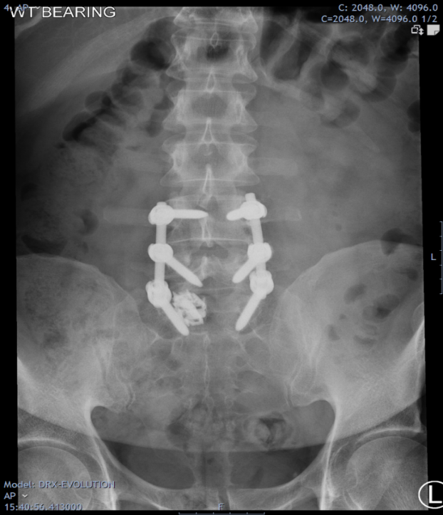

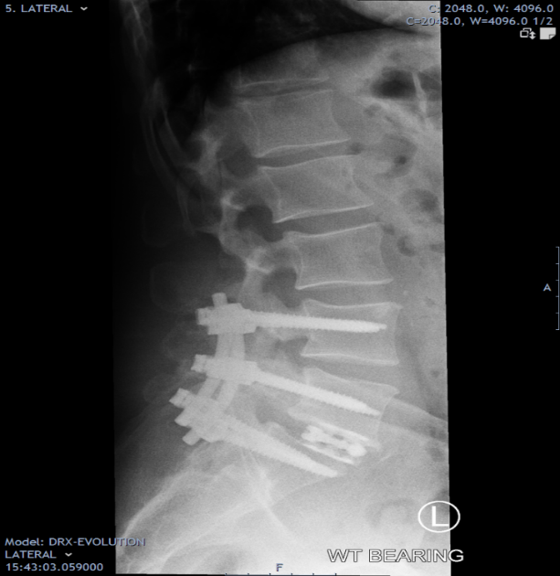

6 m F/U:
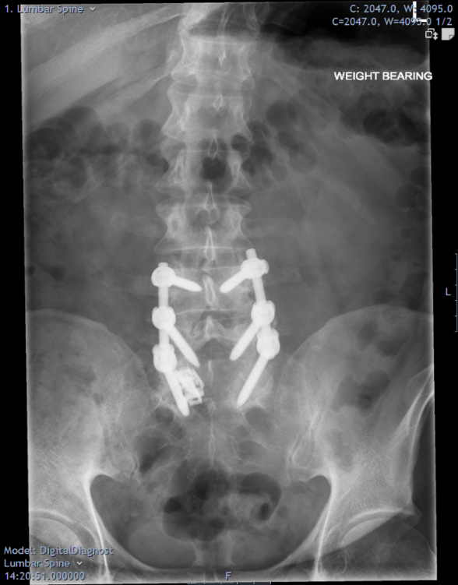

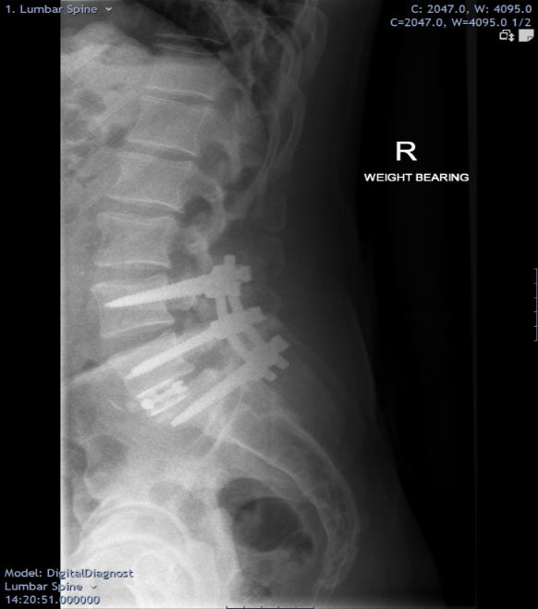

4. Discussion:
The goal of lumbar interbody fusion is to mainly relieve leg pain due to nerve root entrapment and achievement of bony fusion at the levels of interest. [11]
PLIF not only relieves the pain resulting from nerve compression by neural decompression of the symptomatic side, but also restores disc height, maintains vertebral alignment, restores weight bearing and reconstructs stability of the segment. PLIF has been reported to obtain a higher rate of fusion of the intervertebral segments and more satisfactory clinical outcomes than posterolateral bone grafting. [12]
The traditional PLIF technique is usually performed by inserting two cages via a bilateral approach with extensive laminectomy or posterior facetectomy and combining bilateral pedicle screws to provide spinal stability. The procedure itself has some disadvantages. Primarily, wide laminectomy, bilateral facetectomy and extensive intraoperative paraspinal muscle exposure around the posterior segments in the procedure increase the trauma and blood loss, causing denervation and atrophy of the paraspinal muscle, which results in a failed back syndrome. [13]
Three types of PLIF have been used:
- The traditional technique is implanting 2 cages through bilateral or a full laminectomy, which is the widespread method.
- The less common method of implanting 2 cages using bilateral 2 small laminar windows.
- The method utilized in this study, implanting only one cage. [14]
Oxland and Lund reported that utilizing one cage with pedicular screws provided adequate stability in all directions, especially in flexion. Moreover, they suggested that using 2 cages may increase the risk of neurological injury. Another potential advantage of a single cage PILF was discussed by Zhao et al. [15] who documented that single-cage PLIF was easier to perform than two-cage PLIF. Using one cage was believed to reduce the manipulation of the nerve roots and dura at the asymptomatic side, thus theoretically reducing the risk of nerve and dural injuries. This applies most to the patients with unilateral nerve root compression (unilateral leg pain/weakness). They also added that single-cage PLIF was advantageous in reducing the blood loss, the operative time and the hospital stay.
In this study, single-cage PLIF minimized the damage to the posterior structures while providing proper decompression, high stability and a remarkable fusion rate, and the cost of an additional cage could be saved.
Oswestry Disability Index (ODI) score showed an overall significant difference (P-value < 0.001). Post hoc analysis revealed that it was significantly higher pre-operative (50) compared to 3 months (20) and 12 months (10). Also, it was significantly higher at 3 months compared to 12 months.
This agrees with Abduljabar et al study on 41 patients with lumbar degenerative disease managed by PLIF. They found out that the ODI averaged 53 preoperatively (SD, 15.99) and had decreased to a mean of 22.73 (SD, 20.14) at the final follow-up. [16]
In our study, two patients showed cage posterior migration, only one was symptomatic. This agrees with Jin et al., they conducted a retrospective study on 75 patients who had lumbar interbody fusions fusion. Of which, five developed cage migration (6.7%). The cages were observed to have migrated posteriorly and more towards the side of the surgery. [17]
However, Bingqian et al. In their study of 31 patients reported no complications, such as infection or neurological deterioration. No broken screw, screw loosening, significant cage migration or subsidence was observed in any of the cases. [18]
In our study, one patient showed screw malposition. This is less than reported by Aslanbaş et al. in their study of 100 patients who had thoracolumbar pedicular screws fixation. They reported 11.85% screw malposition of 692 screws inserted in this patient cohort. [19]
On the other hand, Woo et al reported a wide range of variability of screw malposition and cortical perforation of the pedicular screws in the literature, ranging from 2% to 50%. [20]
One patient in our study showed superficial infection that resolved with oral antibiotics. This agrees with Dowell et al. review article on postoperative spinal infections that stated that the incidence of such infections range from 0% to 18%. Moreover, the infection incidence increased to 6% to 18% with instrumented fusion. [21]
In our study the Patients’ satisfaction reported that most patients (70.0%) reported excellent outcomes. Only 20% and 10% reported good or fair outcomes. This was in agreement with Zhao who conducted their study on 27 patients with posterior lumbar interbody fusion with a single cage, 55% of the patients had an excellent outcome, 37% had a good outcome and 3.7% had a fair or poor outcome. Moreover, they reported a 92.5% of achieving fusion at 1 year and all the patients achieved arthrodesis at 2 years. They concluded that using a single cage with supplementation of pedicular screws is a safe, easy and a more economical way to achieve PLIF. [22]
Fogel et al [23] conducted retrospective study of 26 consecutive patients treated with a unilateral cage asks whether fusion healing and clinical outcome is comparable with that obtained with bilateral cages. In this study, there were no pseudarthroses, instrumentation failures, or significant subsidence at any of the single cage levels. Disc space height and foraminal height were restored by the surgery and maintained at last follow-up. Using Prolo scores, 23/26 patients had clinical success (88%), and 3 were unsuccessful. Fusion was successful at all single cage fusion levels and overall in 23/26 (88%) reviewing all levels of fusion. The study conclusion was, fusion and clinical success rates were not diminished by the use of a unilateral interbody cage rather than the recommended 2 cages. This retrospective comparative study is a Level III-2 Therapeutic Study investigating the results of unilateral PLIF with a single interbody cage compared with historical series with interbody cages.
Bingqian et al. conducted a study on Thirty-one patients with unilateral radiculopathy who were diagnosed with spinal stenosis along with degenerative disc disease and a herniated intervertebral disc with lumbar instability underwent a unilateral PLIF using a single cage and unilateral pedicle screws. The postoperative clinical evaluation was based on the visual analogue scale (VAS) and the Oswestry Disability Index (ODI) for back pain and leg pain at multiple time points following the surgery. Radiological assessments were performed with lateral plain radiographs taken preoperation, immediately postoperation, 1, 2, 3 and 6 months postoperation and at the most recent follow-up. The patients all underwent a single-level fusion, and the mean duration for the surgeries was 94 min. The mean haemorrhage volume was 250 ml, and no blood transfusion was required for any of the cases. Twelve months postoperatively, all patients had achieved an Excellent or Good outcome (Excellent in 28 patients and Good in 3). The mean pain score was 6.8 prior to surgery and decreased to 2.3 at the 3-month postoperative examination. No significant complications or neurological deterioration occurred. None of the 31 patients appeared to have any fusion failure. No broken screw, screw loosening, significant cage migration or subsidence was observed in any of the cases. The study conclusion was Conducting PLIF using the diagonal insertion of a single cage with supplemental unilateral transpedicular screw instrumentation enables sufficient decompression and solid interbody fusion to be achieved with minimal invasion of the posterior spinal elements. This technique is a more clinically secure, straightforward and cost-effective way to perform PLIF. [18]
Performing unilateral PLIF using a single interbody cage has several advantages. Inserting a single interbody cage through a unilateral approach compromises fewer anatomic structures than two cages inserted through a bilateral approach. However, it is unknown that unilateral PLIF can achieve biomechanical stability as the bilateral PLIF. Suke et al. [12] found that unilateral pedicle screw fixation was as effective as bilateral pedicle fixation in lumbar spinal fusion independent of one or two levels. Their conclusions cannot extend to the cage-instrumented PLIF due to the different boundary of decompression (especially facetectomy). Tencer et al. demonstrated that two PLIF structural devices produced a greater reduction in torsional stiffness than single PLIF device. [24]
Chen et al. demonstrated that unilateral fixation with two cage insertion is a feasible alternative in spinal surgery. Wang et al. [25] showed that an oblique insertion of a single BAK cage in instrumented PLIF might reduce exposure and enable precise implantation. These articles could not provide enough evidence to support that unilateral fusion can supply similar stability as the bilateral fusion. That is why unilateral PLIF did not become routine procedures in the treatment of degenerative lumbar spine disease. [26]
Goel et al. demonstrated that the unilateral plate system causes coupled motions due to its inherent asymmetry and was unlikely to provide sufficient rigidity in fresh cadaveric human spines. Rotational deformity of lumbar spine might develop if inherent asymmetry persisted. They considered complete excision of the disc was required. Unilateral cage-instrumented PLIF might overcome inherent asymmetry. From the previous review, this study was conducted with two aims. One was to know the biomechanical stability between unilateral and bilateral cage-instrumented PLIF. The other was to determine the unpleasant effect of couple motion resulting from inherent asymmetry was present or not in the unilateral group. [27]
5. Conclusion:
Single cage in posterior lumbar interbody fusion for treatment of lumbar instability enables sufficient decompression and produce satisfactory clinical outcomes and radiological outcomes such as maintaining the proper intervertebral disc space, good boney union, rigid stability and a high fusion rate.
6. References:
[1] A. Leone ,G. Guglielmi ,V. Cassar-Pullicino,L.Bonomo.Lumbarintervertebral instability: a review. Radiology. 2007 Oct;245(1):62-77.
[2] S.Stevenson ,S. Emery ,V. Goldberg. Factors affecting bone graft incorporation. Clin Orthop Relat Res 1996;324:66-74.
[3] R.Mobbs ,M. Chung and P. Rao : Bone graft substitutes for anterior lumbar interbody fusion. Orthop Surg, 2013, 5: 77–85.
[4] K. Hasegawa, H. Shimoda, K. Kitahara, K. Sasaki, T. Homma: What are the reliable radiological indicators of lumbar segmental instability? J Bone Joint Surg [Br] 2011;93-B:650-7.
[5] M. Modic,T. Masaryk ,J. Ross,J. Carter. Imaging of degenerative disk disease. Radiology 1988; 168:177–186.
[6] H. Murakami ,W. Horton ,N. Kawahara ,K. Tomita ,W. Hutton (2001) Anterior lumbar interbody fusion using two standard cylindrical threaded cages, a single mega-cage, or dual nested cages: a biomechanical comparison. J Orthop Sci(6):343–348
[7] D.Resnick ,T. Choudhri ,A. Dailey (2005) Guidelines for the performance of fusion procedures for degenerative disease of the lumbar spine. Part 9: fusion in patients with stenosis and spondylolisthesis. J Neurosurg Spine.; (2):679–85
[8] P.Mummaneni ,R. Haid ,G. Rodts. (2004) Lumbar interbody fusion: state-of-the-art technical advances. Invited submission from the Joint Section Meeting on Disorders of the Spine and Peripheral Nerves, March. J Neurosurg Spine. ;( 1):24–30.
[9] J.Brantigan ,B. Cunningham ,K. Warden. Compression strength of donor bone for posterior lumbar interbody fusion. Spine. 1993; 18:1213–1221.
[10] H.Shin ,S. Yi ,K. Kim ,S. Kim ,D. Yoon .Posterior Lumbar Interbody Fusion via a Unilateral Approach. Yonsei Med J. 2006 Jun; 47(3):319-325.
[11]J. Wang,P. Mummaneni,R. Haid. Current treatment strategies for the painful lumbar motion segment: posterolateral fusion versus interbody fusion. Spine. 2005; 30 (suppl 16):S33–S43.
[12] J.Zhao ,Y. Hai ,N. Ordway,C. Park,H. Yuan. Posterior lumbar interbody fusion using posterolateral placement of a single cylindrical threaded cage. Spine (Phila Pa 1976). 2000;25 (4):425–30.
[13] T. Motosuneya,T. Asazuma,T. Tsuji, H.Watanabe,Y. Nakayama, K. Nemoto . Postoperative change of the cross-sectional area of back musculature after 5 surgical procedures as assessed by magnetic resonance imaging. J Spinal Disord Tech. 2006; 19:318–22.
[14] R.Molinari,J. Sloboda ,F. Johnstone. Are 2 cages needed with instrumented PLIF? A comparison of 1 versus 2 interbody cages in a military population. Am J Orthop. 2003; 32(7):337-43.
[15] G. Jones ,J. Butler ,I. Lieberman, and R.Schlenk. Negative-pressure wound therapy in the treatment of complex postoperative spinal wound infections: complications and lessons learned using vacuum-assisted closure. J Neurosurg Spine. 2007; 6:407–11.
[16] F.Abduljabbar ,A. Makhdom , M. Rajeh M, et al. Factors Associated With Clinical Outcomes After Lumbar Interbody Fusion With a Porous Nitinol Implant. Global Spine J. 2017;7(8):780-786.
[17] L. Jin ,Z. Chen ,C. Jiang ,Y. Cao Migration after unilateral instrumented transforaminal lumbar interbody fusion and associated risk factors: a modified measurement method. J Int Med Res. 2020;48(2):300060519867828.
[18] C. Bingqian , X. Feng , S. Xiaowen, Z.Feng,F. Xiaowen ,Q. Yufeng ,D. Qirong. Modified posterior lumbar interbody fusion using a single cage with unilateral pedicle screws: a retrospective clinical study. J Orthop Surg Res. 2015 Jun 30; 10:98..
[19] O.Aslanbaş ,K. Oktay ,K. Özsoy. (2018). Assessment of pedicle screw malposition rates in thoracolumbosacral spine: results of postoperative computed tomography in 100 patients. Cukurova Medical Journal.
[20]E.Woo,M. DiCuccio. Clinically significant pedicle screw malposition is an underestimated cause of radiculopathy. Spine J. 2018;18(7):1166-1171
[21]J. Dowdell, R.Brochin ,J. Kim. Postoperative Spine Infection: Diagnosis and Management. Global Spine J. 2018;8(4 Suppl):37S-43S.
[22] J.Zhao,X. Wang ,T. Hou ,S. He . One versus two BAK fusion cages in posterior lumbar interbody fusion to L4-L5 degenerative spondylolisthesis: a randomized, controlled prospective study in 25 patients with minimum two-year follow-up. Spine. 2002; 27:2753
[23] R. Fogel ,J. Toohey , A. Neidre . Is one cage enough in Posterior Lumbar Interbody fusion? J Spinal Disorder Tech Feb 2007; 20. 60-5. 10.1097.
[24] A.Tencer,D. Hampton,S. Eddy Biomechanical properties of threaded inserts for human interbody spinal fusion. Spine. 1995; 20:2408–2414.
[25] Oxland TR, Lund T. Biomechanics of stand-alone cages and cages in combination with posterior fixation: a literature review. Eur Spine J. 2000;9 Suppl 1:S95-101.
[26] H. hen ,B. Cheung ,W. Wang ,A. Li , K. Li . Biomechanical analysis of unilateral fixation with interbody cages. Spine. 2005;30:E92–96.
[27] V. Goel, T. Lim, J. Gwon ,J. Chen ,J. Winter bottom ,J. Park ,J. Weinstein , J.Ahn . Effects of rigidity of an internal fixation device. A comprehensive biomechanical investigation. Spine. 1991; 16:S155–161.

